Spike 4: Advanced Visual Studio

**Development vs Release configs:**



You can change the configuration independently for each config.

**Pre-processor macros:**

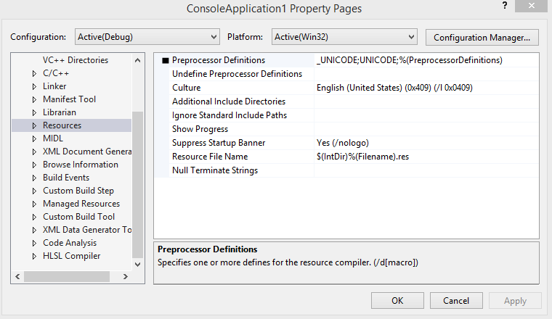

**Adding pre-processor macros:**

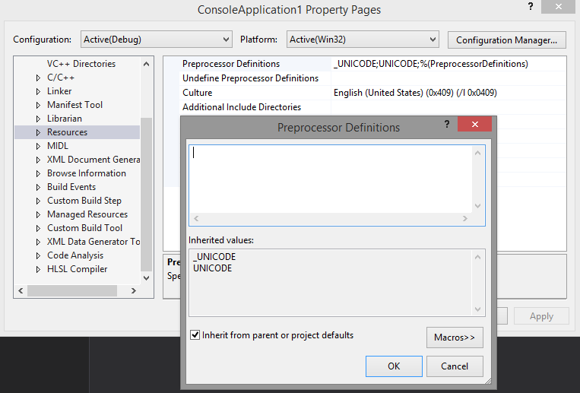

**Launch the debugger with command-line parameters:**

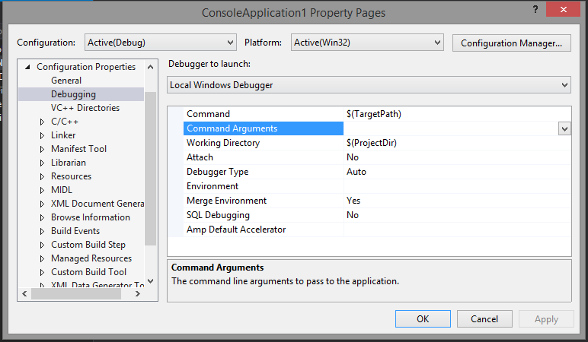

**Add additional include directories:**

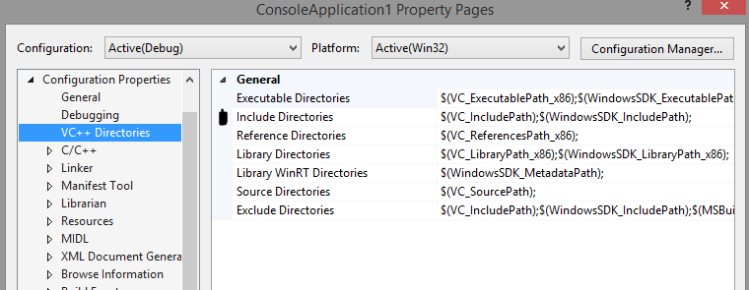

**Optimisation settings for a VS project:**

**Link against libraries for compilation:**